

Semester One Examination, 2021

Question/Answer booklet

MATHEMATICS  
SPECIALIST  
UNIT 1

If required by your examination administrator, please place your student identification label in this box

Section One:  
Calculator-free

|  |  |  |  |  |  |  |  |  |  |  |
| --- | --- | --- | --- | --- | --- | --- | --- | --- | --- | --- |
| WA student number: In figures |  |  |  |  |  |  |  |  |  |  |

In words

Your name

|  |  |
| --- | --- |
| Number of additional answer booklets used (if applicable): |  |

## Time allowed for this section

Reading time before commencing work: five minutes

Working time: fifty minutes

## Materials required/recommended for this section

***To be provided by the supervisor***

This Question/Answer booklet

Formula sheet

***To be provided by the candidate***

Standard items: pens (blue/black preferred), pencils (including coloured), sharpener,  
correction fluid/tape, eraser, ruler, highlighters

Special items: nil

## Important note to candidates

No other items may be taken into the examination room. It is **your** responsibility to ensure that you do not have any unauthorised material. If you have any unauthorised material with you, hand it to the supervisor **before** reading any further.

## Structure of this paper

|  |  |  |  |  |  |
| --- | --- | --- | --- | --- | --- |
| Section | Number of questions available | Number of questions to be answered | Working time (minutes) | Marks available | Percentage of examination |
| Section One: Calculator-free | 8 | 8 | 50 | 50 | 35 |
| Section Two: Calculator-assumed | 13 | 13 | 100 | 92 | 65 |
|  | | |  | **Total** | 100 |

|  |  |  |
| --- | --- | --- |
| Markers use only | | |
| Question | Maximum | Mark |
| 1 | 5 |  |
| 2 | 6 |  |
| 3 | 6 |  |
| 4 | 4 |  |
| 5 | 8 |  |
| 6 | 6 |  |
| 7 | 7 |  |
| 8 | 8 |  |
| S1 Total | 50 |  |
| S1 Wt (×0.7) | 35% |  |
| S2 Wt | 65% |  |
| Total | 100% |  |

## Instructions to candidates

1. The rules for the conduct of examinations are detailed in the school handbook. Sitting this examination implies that you agree to abide by these rules.

2. Write your answers in this Question/Answer booklet preferably using a blue/black pen.  
Do not use erasable or gel pens.

3. You must be careful to confine your answers to the specific question asked and to follow any instructions that are specific to a particular question.

4. Show all your working clearly. Your working should be in sufficient detail to allow your answers to be checked readily and for marks to be awarded for reasoning. Incorrect answers given without supporting reasoning cannot be allocated any marks. For any question or part question worth more than two marks, valid working or justification is required to receive full marks. If you repeat any question, ensure that you cancel the answer you do not wish to have marked.

5. It is recommended that you do not use pencil, except in diagrams.

6. Supplementary pages for planning/continuing your answers to questions are provided at the end of this Question/Answer booklet. If you use these pages to continue an answer, indicate at the original answer where the answer is continued, i.e. give the page number.

7. The Formula sheet is not to be handed in with your Question/Answer booklet.

Section One: Calculator-free 35% (50 Marks)

This section has**eight** questions. Answer **all** questions. Write your answers in the spaces provided.

Working time: 50 minutes.

Question 1 (5 marks)

(a) In the circle shown, chords $AC$ and $BD$ intersect at $E$, $∠ADE=27°$ and $∠DEC=84°$.  
  
Determine the size of angles $α$ and $γ$. (2 marks)

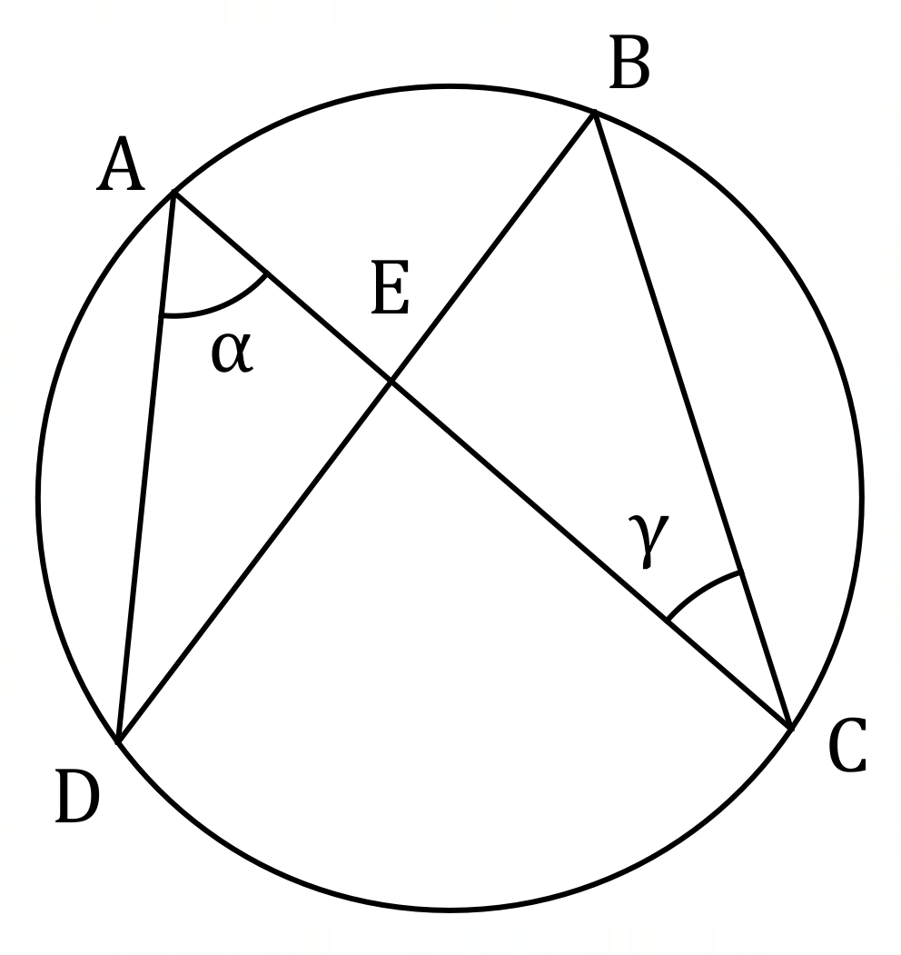

(b) In the circle below, $PQRS$ is a cyclic quadrilateral and $XY$ is a tangent to the circle at $P$.  
  
Given that $∠XPQ=72°$ and $∠PQS=53°$, determine $∠QRS$. (3 marks)

<EFOFEX>
id:fxd{d2085924-1b3c-41a1-bb79-78f9df548c35}

FXData:
</EFOFEX>

Question 2 (6 marks)

Points $A, B, C$ and $D$ lie on the circumference of a circle so that the chords $AC$ and $BD$ intersect at point $E$.

(a) Sketch a diagram to show triangle $ADE$ and triangle $BCE$ and prove that they are similar.

(4 marks)

(b) In the case when the lengths of $BE, CE$ and $DE$ are $7$ cm, $4$ cm and $6$ cm respectively, determine the length of $AE$. (2 marks)

Question 3 (6 marks)

Let $a=3i-6j$ and $b=-i+j$.

(a) Determine $\left|2a+3b\right|$. (3 marks)

(b) Determine the vectors $m$ and $n$ given that $2a+b=m-n$ and $2b-a=2m+n$.

(3 marks)

Question 4 (4 marks)

<EFOFEX>
id:fxd{c96a36c0-ce7d-43db-b4d9-28ecbacbafa7}

FXData:
</EFOFEX>In the diagram, $BD$ is a tangent at $C$ to  
the circle with centre $O$, $OB$ intersects  
the circle at $A$ and chord $AE$ is parallel  
to tangent $BD$.  
  
Determine the size of $∠ECD$ when  
the size of $∠ABC=38°$.  
  
Justify your answer.

Question 5 (8 marks)

(a) Determine the vector(s) that are parallel to $7i+j$ and have the same magnitude  
as $4i-3j$. (4 marks)

(b) Two vectors are $2i+\left(2λ+1\right)j$ and $-7i+\left(λ-1\right)j$, where $λ$ is a constant.  
  
Determine the value(s) of $λ$ so that the vectors are perpendicular. (4 marks)

Question 6 (6 marks)

<EFOFEX>
id:fxd{7a791319-a0d8-45a3-9d2b-f2944fa2b72b}

FXData:
</EFOFEX>The diagram shows parallelogram $PQRS$.

A theorem states that the sum of the squares of  
the lengths of the diagonals of a parallelogram  
is equal to the sum of the squares of the lengths  
of its sides.

(a) Complete the following expression of the theorem using vector notation:

(1 mark)

${\left|\vec{PR}\right|}^{2}+{\left|\vec{QS}\right|}^{2}=$

(b) Letting $\vec{PQ}=q$ and $\vec{PS}=s$, use a vector method to prove the theorem. (5 marks)

Question 7 (7 marks)

Points $A, B$ and $C$ have position vectors $(-5, -4)$, $(7, 0)$ and $(-2, 7)$ respectively.

(a) Determine the position vector of $M$, the midpoint of $A$ and $B$. (1 mark)

(b) Determine the vectors $\vec{AB}$ and $\vec{CM}$. (1 mark)

(c) Show that $\vec{AB}$ and $\vec{CM}$ are perpendicular. (2 marks)

(d) Hence, or otherwise, determine the area of triangle $ABC$. (3 marks)

Question 8 (8 marks)

(a) Show that $3\left(\begin{matrix}5 \\ 2\end{matrix}\right)=5\left(\begin{matrix}4 \\ 2\end{matrix}\right)$. (2 marks)

(b) Show that $\left(n-k\right)\left(\begin{matrix}n \\ k\end{matrix}\right)=n\left(\begin{matrix}n-1 \\ k\end{matrix}\right)$ for all $n$ and $k$ that are positive integers, $n>k$.

(4 marks)

(c) Hence, or otherwise, evaluate $\left(\begin{matrix}60 \\ 55\end{matrix}\right)$, given that $\left(\begin{matrix}59 \\ 55\end{matrix}\right)=455 126$. (2 marks)

Supplementary page

Question number: _________

© 2021 WA Exam Papers. Kennedy Baptist College has a non-exclusive licence to copy and communicate this document for non-commercial, educational use within the school. No other copying, communication or use is permitted without the express written permission of WA Exam Papers. SN245-171-1.